1. Bayes' Theorem

Bayes' theorem is a basic element of probability theory first discovered or codified by the British statistician, Thomas Bayes.

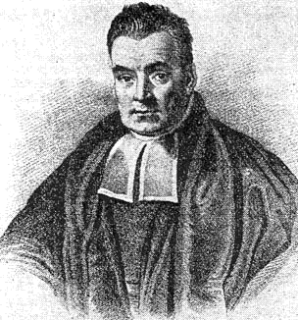
Rev. Thomas Bayes (c. 1701 – 1761)

At the most basic level, Bayes' theorem is an equation that relates two conditional probabilities, P(B|A) and P(A|B).

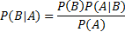

This formula is easily derived from the definition of conditional probability and the multiplication rule. (In fact, it would be a fairly straightforward homework assignment.) An intermediate step in the derivation is the equation:

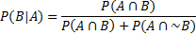

Despite its simplicity, from Bayes' Theorem a whole new approach to statistics develops.

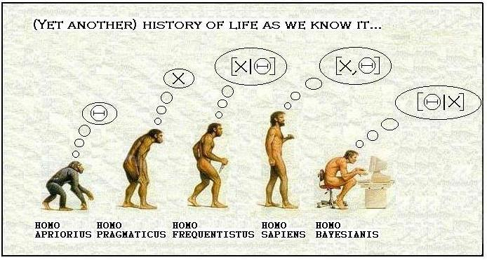

Importance of Bayes' Theorem

It could rightly be said that today the field of statistics is being gradually transformed by Bayes' theorem, producing a new field of Bayesian statistics.

This revolution not only has immense potential for scientific research, but for fundamentally changing how probabilistic thinking occurs in human culture. Bayesian statistics:

- Is arguably a superior way of thinking about and using probabilities.
- Has the potential to transform every discipline that draws inferences from uncertain evidence (medicine, law, quality analysis…)
- Helps us to see that many important inferences are only probabilistic, not certain
- Requires us to identify and explicitly quantify the components of probabilistic inference.
- Makes everyday probabilistic inferences less vague and subjective

Bayes' Theorem and Scientific Inference

While we cannot go into much detail here, a simple example helps illustrate why Bayesian statistics is of such fundamental importance.

Let:

H = a scientific hypothesis (e.g., about a population mean)

E = observed evidence (e.g. a sample mean).

It should be obvious that the purpose of scientific research is to collect evidence in order to evaluate a hypothesis. In other words, our principle concern is to estimate the probability that a hypothesis is true, given empirical evidence, or P(H | E).

Yet conventional statistical theory examines the reverse question: what is the probability of the evidence we've observed occurring, given some hypothesis, or P(E|H). For example, the whole system of statistical significance testing is built around estimating the likelihood of observed results given a null hypothesis. This is completely backwards. It means we're estimating the probability of something we already know (our data), given something we don't know (our hypothesis). It is this logical backwardness that makes null hypothesis testing and p-values so non-intuitive and confusing.

Clearly the correct order of scientific inference is to estimate what we don't already know (our hypothesis), given what we do know (our evidence).

But by Bayes' theorem, we see that these two conditional probabilities are related:

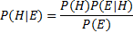

And this, more or less, is what opens up the whole realm of Bayesian statistics.

Many advanced applications (e.g., Google spam filters and language translators) already use Bayesian methods. Bayesian methods will likely become more and more common in the coming decades.

